**//Om Shree Gurubhyo Namaha//**

**VARICOSE VEINS DIAGNOSIS**

***- R. Subha Lekha***

*and happy life, free from sorrow and sufferings caused by diseases or accidents. 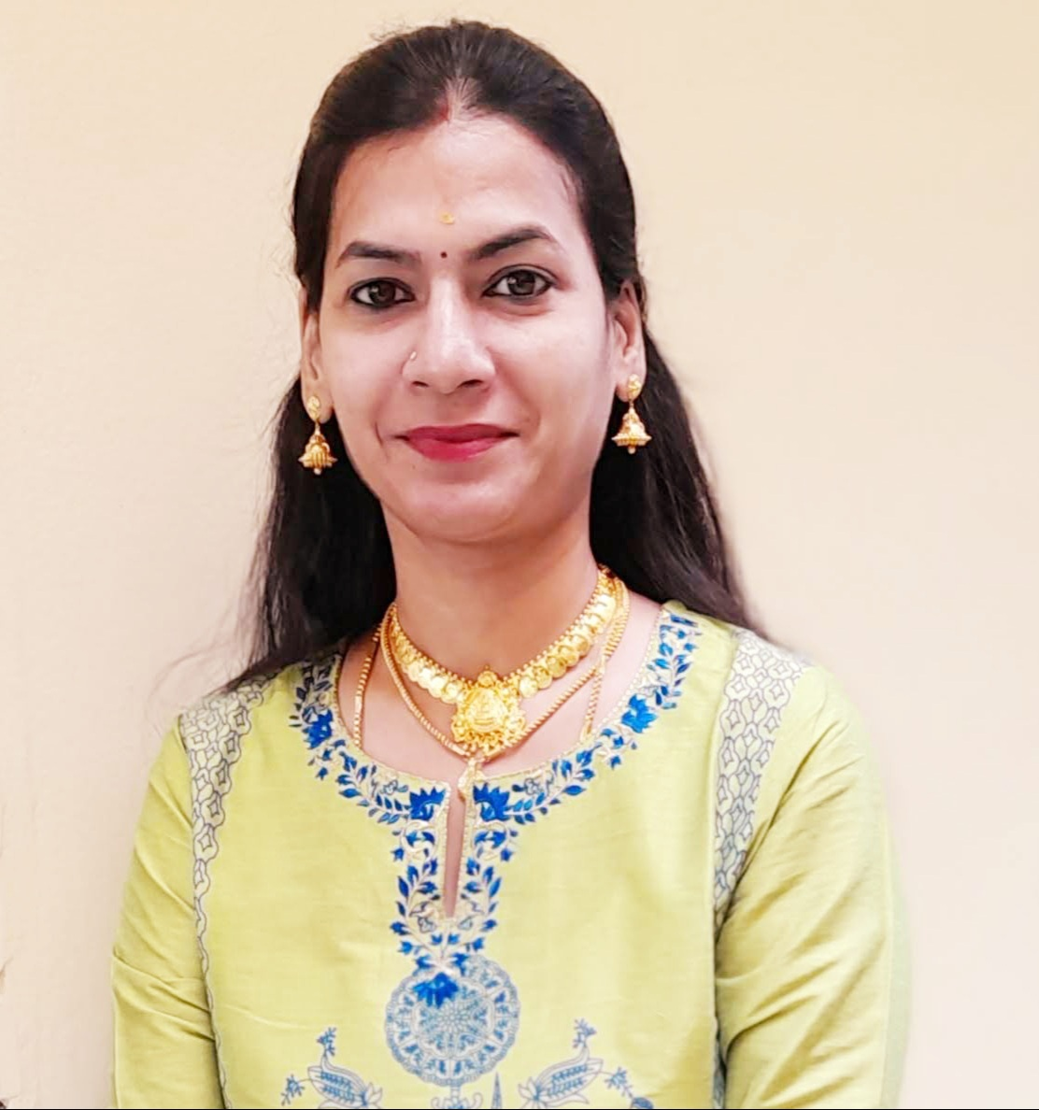R.Subha Lekha is a Research Scholar of JKR Astro Research Foundation. She pursued her Masters in Vedanga Jyotisha holding First Rank from Yoga Samskrutham University, Florida USA. Presently she is pursuing her PhD in Medical Astrology under the guidance of Dr. N.V.R.A. Raja sir. She is by profession Astro Consultant.*

*Author’s Note :*

*I am glad that I have got an opportunity to write an article about Varicose Veins applying Kalamsa rule.* *Medical astrology is a science that demands a union of knowledge of both astrology and medicine. Ideally, it takes years of acquiring astrological expertise and then becoming totally familiar with physiology and anatomy to qualify as a medical astrologer who with the cooperation of physician can accurately diagnose diseases and advise clients on the best procedures for regaining health. A horoscope indicates good, bad and indifferent conditions in nature and cosmos at the moment of birth of a native. By proper delineation of the horoscope, one can find out good, bad or indifferent traits and characteristics of the native and also these parameters of nature.*

Medical astrology can be a lifetime guide for timely preparation for a healthy and happy life, free from sorrow and sufferings caused by diseases or accidents.

Medical astrology is very important science. Astrologers have been predicting diseases through various combinations in the horoscope. “I believe that astrology and complementary medicine will help take the huge pressure off doctors. Medical astrology is useful diagnostic tool which enables us to see strengths and weaknesses via the birth chart. Astrology offers self understanding to people. People who oppose what I say are usually bullies who never studied astrology. Astrology was until modern times, a part of the tradition of medicine.”

An attempt has been made to diagnose the disease astrologically through divisional charts. The approach is to pinpoint the location and type of disease. This have been applied and tested on hundreds of horoscopes with high accuracy.

In this research work, an attempt was made to apply the theory of concept linking the Karaka planets and its **Kalamsa Lords** to Vimshottari Dasa system to arrive at the timing of events of a bhava or karaka as advocated by **Jr. Meena 2 my Guruji Naadi Jyotisha Kesari Dr. NVRA Raja garu**. I have applied the Kalamsa principles by using the stellar dispositor theory advocated by Meena 2 Naadi and observed that almost all the major events of a native have connection with Kalamsa Lords at the time of fructification of event and also they have connection with Dasa, Bhukti and Antara lords in Gochara/transit.

**What is Varicose Veins Disease?**

* Gnarled1, enlarged veins, most commonly appearing in the legs and feet.
* Varicose veins are large, swollen veins that often appear on the legs and feet. They happen when the valves in the veins do not work properly, so the blood does not flow effectively. The veins rarely need treatment for health reasons, but if swelling, aching, and painful legs result, and if there is considerable discomfort, treatment is available.
* Varicose veins are generally benign2. The cause of this condition is not known. For many people, there are no symptoms and varicose veins are simply a cosmetic concern. In some cases, they cause aching pain and discomfort or signal an underlying circulatory problem.
* Treatment involves compression stockings, exercise or procedures to close or remove the veins.

**Cause :** People who have jobs wherein they mostly stand acquire this problem fast (ex. Teachers, Sportsmen, Traffic Police, Security, Bus conductors, etc.).  Now-a-days software professionals who continuously sit in their seats succumb to this dysfunction, due to lack of blood circulation to the lower parts of the limbs.

**Cure:** Since it is a permanent damage to the valves and they cannot be replaced, there are very less options for cure. Wearing stockings gives relief and delays the advancement of the problem to next stages. In cases where there is no use of stockings, the veins are removed. In this case the person suffers from pain for almost a year until other subsidiary veins take up the load.

**Effect:** Initially this results in cramps and pain in the legs. It becomes difficult to climb stairs or stand for a long time. In the second level, there is visible dark coloration of the veins in the legs. In the third level, the veins swell and protrude out so that one can feel by moving their hand on the affected area. In severe cases there is internal bleeding due to vein rupture and later may cause bacterial infection.

1. Rough and twisted, especially because of old age or no protection from bad weather.

2. Not harmful in effect.

**Planetary Combinations in horoscope which generally causes Varicose Veins Disease :**

**Saturn the significator of legs is afflicted by conjunction with Rahu and the 10th lord Moon.**

* Sun – Potency of blood
* Moon – The watery portion of blood
* Mars – Red Blood Corpuscles (RBC), Eruptions of the skin
* Mercury – Skin
* Jupiter – Lipids and Obesity
* Venus – Veins
* Saturn – Legs and feet
* Rahu – Swelling and Toxic matter
* Ketu – Stoppage of blood and Surgery

**Houses/bhavas and their lords which are to be considered :**

* 9th House – Upper part of the thighs
* 10th House – Lower part of the thighs
* 11th House – Calf muscles and shin bone area
* 12th House – Feet below the ankle
* 6th House – Lord of diseases
* 8th House – Chronic diseases, surgery
* 12th House – Feet, hospitalization

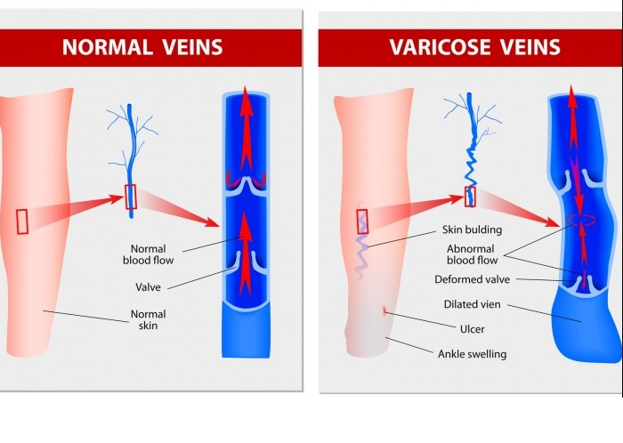

**CHART NO.1**

**D.OB :- 19.04.1981 T.O.B:- 19:38 P.O.B :- Secunderabad, Telangana.**

|  |  |  |  |
| --- | --- | --- | --- |
| **ME** | **MA, SU, VE** |  |  |
|  | **NATAL CHART** | | **RA** |
| **KE** |  |
|  |  | **ASC, MO** | **(JU), (SA)** |

|  |  |  |
| --- | --- | --- |
| **PLANET** | **STAR** | **PADA** |
| ASC | Visakha | 1 |
| SUN | Ashwini | 2 |
| MOON | Swathi | 1 |
| MARS | Ashwini | 1 |
| MERCURY | Revathi | 4 |
| JUPITER | Uttara | 4 |
| VENUS | Ashwini | 3 |
| SATURN | Hastha | 1 |
| RAHU | Pushyami | 3 |
| KETU | Sravanam | 1 |

|  |  |  |  |  |  |  |  |  |  |
| --- | --- | --- | --- | --- | --- | --- | --- | --- | --- |
| **H.NO** | **HL** | **HL Star** | **HL GU** | **HL JP** | **HL SP** | **KL** | **KL GU** | **KL JP** | **KL SP** |
| 1 | LP | Visakha -1 | - | - | - | Ju | RSS | Ma | Ke |
| 1,8 | Ve | Ashwini -3 | TTS | Ke | Mo | Ju | RSS | Ma | Ke |
| 2,7 | Ma | Ashwini -1 | TST | Ke | Mo | Ve | TTS | Ke | Mo |
| 3,6 | Ju | Uttara -4 | RSS | Ma | Ke | Ve | TTS | Ke | Mo |
| 4,5 | Sa | Hastha -1 | RTT | Mo | Ra | Mo | TRS | Ra | Ju |
| 9,12 | Me | Revathi -4 | STS | Me | Ju | Ju | RSS | Ma | Ke |
| 10 | Mo | Swathi -1 | TRS | Ra | Ju | Ra | TRR | Ju | Ma |
| 11 | **Su** | Ashwini -2 | TSR | Ke | Mo | **Ra** | TRR | Ju | Ma |
| - | Ra | Pushyami -3 | TRR | Ju | Ma | Ra | TRR | Ju | Ma |
| - | Ke | Sravanam -1 | RST | Mo | Ra | Ra | TRR | Ju | Ma |

**KL- Kalamsa Lord, KLGU-Kalamsa Lord Guna,KLJP-Kalamsa Lord Jeeva Planet, KLSP-Kalamsa**

**Lord Sareera Planet**

**Principle for Consideration**

* **If Saturn or Kalamsa lord of Saturn has connections with 5th house or 5th kalamsa lord and 11th house or 11th kalamsa lord with strong yogakarakadipati connections during the period of DBA in transit, then chances of recovery is indicated.**

**Analysis**

* **Lagnalord and 8th Lord Venus** is in 7th house of maraka sthana conjoined with marakadipathi Mars and badakadipathi Sun. Venus is in the star of Ketu (karaka for surgery/ cutting).
* **6th lord Jupiter** is posited in 12th house along with Saturn the karaka for Varicose. Jupiter and Mercury are in **Sthoola Parivarthana**. Jupiter is in retro. Jupiter represents the body parts thigh, hip region, fat, lungs, karaka for expansion, obesity.
* **12th lord Mercury** is posited in 6th house of roga arambha and is in its own star. Mercury is aspected by 6th lord Jupiter and karaka Saturn from 12th house (hospitalization, expenses). Mercury represents the body parts skin, veins.
* **Saturn** the 4th and 5th lord posited in 12th house is in the star of Moon. Saturn represents the parts of the body are Legs, Joint bones, Limbs, knees etc. Diseases it causes damage and loss of limbs, bone fracture, rheumatic pains, **varicose veins**, etc.
* **Mars** karaka for RBC, blood vessels, is posited in 7th house (Aries sign). Mars is the marakadipathi and is in conjunct with badakadipati Sun and 8th lord Venus.
* **Rahu** delivers the results of Sign lord – Moon, Star lord – Saturn (karaka for Varicose), aspected by Mars (marakadipati). Rahu represent body parts feet, breathing, neck. Diseases it causes are disease in feets, poisoning, varicose veins, etc.
* **Ketu** delivers the results of Sign lord – Saturn (karaka for Varicose), Star lord – Moon, aspected by Jupiter (6th lord). Ketu represents the body parts belly, feet.

|  |  |  |  |
| --- | --- | --- | --- |
| **ME** | **MA, SU, VE** |  |  |
|  | **SA/VE/RA** | | **RA** |
| **KE** |  |
|  |  | **MO** | **(JU), (SA)** |

The native was diagnosed of VVD during **Saturn Dasa – Venus Bhukti and Rahu Antara**

* **Dasalord Saturn** the 4th and 5th lord is posited in 12th house. Saturn is conjoined with 6th lord Jupiter. Saturn in retro gives the result of Sun who happens to be the 11th lord posited in 7th house. Saturn aspects the 12th lord Mercury posited in 6th house (roga sthana).
* **Kalamsa lord of Saturn is Moon,**  the lord of 10th is posited in lagna kendra in the star of Rahu (sanivath rahu)
* **Bhuktilord Venus,** the 8th lord is posited in 7th house in the star of Ketu. Venus is in conjunction with Badakadipati Sun and Marakadipati Mars.
* **Antara lord Rahu** is posited in 10th house in Moon sign (who happens to be the kalamasa lord of Saturn) and is in the star of Saturn (karaka for Varicose).
* **Sun the 11th lord,** is in 7th house and is in the star of Ketu. Kalamsa lord of Sun is Rahu who happens to be the karaka for varicose (Sanivath rahu).

|  |  |  |
| --- | --- | --- |
| **H NO.** | **HL** | **KL** |
| **5th** | **Saturn** | **Moon** |
| **11th** | **Sun** | **Rahu** |

**Yogakarakadipati ------ Mercury**

The native had surgery for Varicose Veins on 31/07/2020.

In transit,

* **Dasalord Saturn** (5th lord) is posited in its own house of Capricorn (natural 10th house of lower part of thighs) is in Sun star (11th lord for the native). Saturn aspects the Rahu who happens to be the kalamsa lord of Sun (11th lord).
* Saturn also aspects natal lagna and Saturn’s kalamsa lord Moon posited in lagna Kendra. Saturn is placed over the natal ketu (karaka for cutting, surgery).
* Saturn aspects natal 12th lord Mercury posited in 6th house.
* Sun is placed over its kalamsa lord Rahu in natal chart.
* Mars marakadipati for the native is in natural 12th house of hospitalization, expenses, etc; aspects natal Saturn (karaka for Varicose) and 6th lord Jupiter. Mars also aspects Moon, the kalamsa lord of Saturn. Mars is placed over the natal Mercury (yogakarakadipati)
* Mercury, yogakarakadipati for the native is with 11th kalamsa lord Rahu posited in its own house.
* **Bhuktilord Venus** is placed in 8th house from natal and is in own house.
* Venus aspected by Moon who happens to be the Kalamsa lord of Saturn the 5th lord in the natal chart.
* In transit Venus in Mrigasira nakshatra, through binnapada 5th lord Saturn aspects Venus from natal chart.
* **Antara lord Rahu** who happens to be the kalamsa lord of Sun(11th lord) is in conjunction with Mercury (yogakarakadipati) and is posited in 9th house from natal. Rahu is aspected by natal Saturn (karaka for varicose).

**Conclusion** : Here, it is to be seen from the above chart, the kalamsa lord of 5th and 11th houses and strong yogakarakadipati connections with karaka Saturn and its kalamsa lord gave the recovery to the native.

**Jai Meena2**

References:

Practical Stellar Astrology-By Guruji Sri NV Raghava Chary (Meena2)

Stellar Effects in Astrology-Kalamsa Gunas-By Dr.NVRA Raja Meena2 Jr.

Stellar Effects in Astrology-Jeeva and Sareera By Dr.NVRA Raja Meena2Jr.

Class Lectures of JKR Astro Research Foundation,Secunderabad

|  |  |
| --- | --- |
| **YK Planets** | Mercury |
| **Digbala Planets** | Su, Ma, Ju, Ve, Sa, Ra, Ke |
| **Bhinnapada Planets** | Ju |
| **Rahu representation** | Mo, Sa, Ma |
| **Ketu representation** | Sa, Mo, Ju |
| **Maraka Planets** | Ma, Ve |
| **Badaka Planets** | Su |